**Python Mega Assignment # 1**

**(Note: Answers are in Bold)**

**1. Which of the following terms are related to dictionaries?**

**a. value**

b. item

c. index

**d. key**

**2. Just like lists, + operator is used to extend dictionaries?**

a. True

b. False

**3. To access items from a dictionary, we specify the index of that item within [] like myDict[0]?**

a. True

**b. False**

**4. When we use [] to access the value from a dictionary which does not exist in that dictionary….?**

a. Value within [] is added to the dictionary

b. Value None is returned

c. New dictionary is created

d. None of above

**5. What does return the pop method of a dictionary?**

a. list

b. tuple containing the pair of last item of the dictionary

c. dictionary

d. value of the key, if it exists in the dictionary

**6. What does return popitem method return?**

a. dictionary

b. tupple containing the pair of last item of the dictionary

c. list

d. value of key, if it exists in the dictionary

**7. Which of the following 2 methods can be used to iterate through the items of a dictionary?**

a. items()

b. values()

c. indexes()

d. keys()

**8. Which one of the following is used to enclose a dictionary?**

a. () parenthesis

b. {} curly brackets

c. [] square brackets

d. “” quotation marks

**9. Write Python Program add key-value pair in dictionary and check if a Given Key or Value or Both Exists in a Dictionary or Not.**

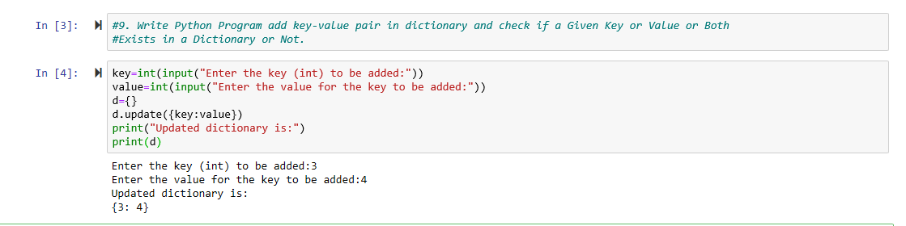

**10. Write a Python Program to Count the Frequency of Words Appearing in a String Using a Dictionary and print only the words having Even (divisible by 2) frequency**

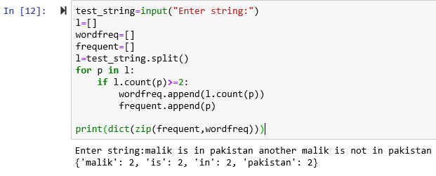

**11. X = ["Feb", Apr, Mar, May, Jun, Jul, Aug, Jan]. What will be output of following?**

**X[0:3] X[2:8]**

**X[4:9]**

**X[1:7:2]**

**X[-1:-7]**

**X[-7:7]**

**X[-1:-8:-2]**

**X[:4]**

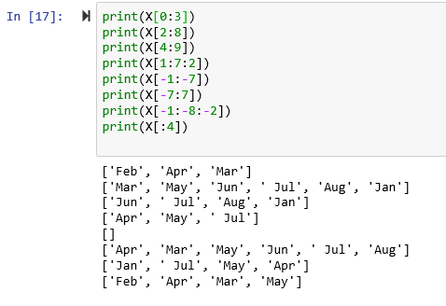

**12. Remove the correct number from the list X X = [ 9,2,8,4,5] X__?__ print (X) Output: [2,8,4,5]**

1) .delete(9)

2) .rm(9)

3) .remove (9)

**13. p = 3 q = 'hello! ' print( q __?__ p) hello! hello! hello!**

1) *

2) **

3) +

**14. y = "this is a random sentence" print (y__?__) Output: THIS IS A RANDOM SENTENCE**

1) .upper()

2) .upcase()

3) .capitalize()

**15. p = True q = ‘True’ r = 2 r = 2.0**

**print(type(p))**

**print(type(q))**

**print(type(r))**

**print(type(s))**

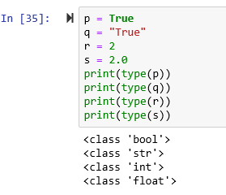

**16. What are the optional arguments to the function? function_1(R1, q, p=None, R2= None)**

1) q and R2

2) p and R2

3) p and R1

4) R1 and q

**17. Which command invokes method X() of the object p?**

1) X(p)

2) p$x()

3) X().p

4) p. x()

**18. X=4 , Y= 2**

**print(X % Y)**

**print(X / Y)**

**print(X // Y)**

**print(Y % X)**

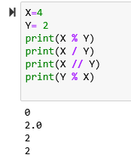

**19. x = [[4, 1, 1],y= [5, 9, 0]] for i in __?__: for j in __?__: ? Output: 4 1 1 5 9 0**

**x = [[4, 1, 1], [5, 9, 0]] for i in __?__: for j in __?__: ? Output: 4 5 1 9 1 0 x = [[4, 1, 1], [5, 9, 0]] for i in __?__: for j in __?__: ? Output: 4 1 1 5 9 0 x = [[4, 1, 1], [5, 9, 0]] for i in __?__: for j in __?__: ? Output: 4 1 1 5 9 0**

**20. q = [10.62, 16.14, 6.45, 17.11] for j, z in enumerate (q) : print( ‘Item ‘ + str( j ) + ‘ - ‘, str ( z )) Output: Item 0 – 10.62 Item 1 – 16.14 Item 2 – 6.45 Item 3 – 17.11 1) z 2) i 3) j 4) x 5) k 6) y**

**21. Which of these about a dictionary is false?**

**a) The values of a dictionary can be accessed using keys**

**b) The keys of a dictionary can be accessed using values**

**c) Dictionaries aren’t ordered**

**d) Dictionaries are mutable**

**22. What is the output of the following: D = dict() for i in range (3): for j in range(2): D[i] = j**

a. {0: 1, 1: 1, 2: 1}

b. {1: 0, 1: 1, 1: 2}

c. {0: 1, 1: 2, 2: 3}

d. {1: 2, 1: 1, 1: 0}

**23. You are writing a function that increments player score in a soccer game If no value is specified for points, then point must start with 1 If no value is specified for bonus, then bonus should be True**

**01 def increment_score ( bonus , score , points ): To meet the first requirement line 01 must be change to θ def increment_score ( bonus , score , points = 1 ): (True)**

**To meet the second requirement line 01 must be change to θ def increment_score ( bonus = True , score , points = 1 ): (True)**

**θ Once a parameter is defined with default value, any parameter to the right must also be defined with default values (True)**

**24. What will be output?**

**def avg ( x , y , z = 50 ):**

**adding = x + y + z**

**avg_value = adding / 3**

**return avg_value**

**y = avg ( x = 5 , y = 9 , z = 20 )**

**print(y)**

**Output: 11.33334**

**25. What will be output? Describe it with reason and logic behind. Do multiple experiments with arguments / parameters to remove error, if occurs. def avg ( *opt_values , name ): avg_value = sum (opt_values) / len(opt_values) print(‘name is: ’ + name + ‘Marks: ’ + str(avg_value)) avg ( 5 , 9 , 20, 34, 87, 112 , ‘Ali’ )**

**Logic:**

**The multiple values argument should be at the right most of parameters, By putting it to end right corner it worked!**

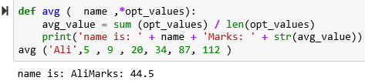

**26. Final output is not required. Just take copy pencil, think and write the output of each line, write down the link between parameters and arguments. Remove one or two ** from other_info and observe the ouput.**

**def display_result(winner, score, **other_info):**

**print("The winner was " + winner)**

**print("The score was " + score)**

**display_result(winner=“Manchester", score="1-0", overtime ="yes", injuries="none")**

The winner was Manchester

The score was 1-0

**27. The position of parameters and arguments is re-arranged. Just think and find the logic behind output or error.**

**def display_result(winner, **other_info, score):**

**print("The winner was " + winner)**

**print("The score was " + score)**

**display_result(winner=“Manchester", overtime ="yes", injuries="none“ , score="1-0“ )**

**The multiple Parameter variable with values should be on right end point python can not recognize the parameter next to the multiple valued parameter.**

**28. What will be the output of the following Python expression if X=123?**

**print(“%06d”%X)**

**a) 123000**

**b) 000123**

**c) 000000123**

**d) 123000000**

**29. What will be the output of the following Python expression if x=22.19?**

**print("%5.2f"%x)**

**a) 22.1900**

**b) 22.00000**

**c) 22.19**

**d) 22.20**

**30. What will be the output of the following Python code?**

**'{0:f}, {1:2f}, {2:05.2f}'.format(1.23456, 1.23456, 1.23456)**

**a) Error**

**b) ‘1.234560, 1.22345, 1.23’**

**c) No output**

**d) ‘1.234560, 1.234560, 01.23’**

**31. Write down the output of each line after each iterations. Do multiple experiments to change values**

**i = 1**

**while False:**

**if i%2 == 0:**

**break**

**print(i)**

**i += 2**

**output: nill**

**as loop is false**

**if change to true then loop iterates infinite times**

**32. Write down the output of each line after each iterations. Do multiple experiments to change values**

**x = "abcdef"**

**i = "a"**

**while i in x:**

**x = x[:-1]**

**print(i, end = " ")**

**output:** a a a a a a

**In first iteration the letter f of x variable is removed and a is displayed in next iteration the next second last letter is removed then in this same way till a is in x variable loop will iterate.**

**33. Write down the output of each line after each iterations. Do multiple experiments to change values**

**for i in ''.join(reversed(list('abcd'))):**

**print (i)**

**output:** d c b a

34. Flow of the program. Write the output of each line after every iteration of ‘i’

for i in range(10):

if i == 5:

break

else:

print(i)

else:

print("Here")

**when i value becomes 5 the loop breaks and the values from 0 to 4 are displayed.**

**35. What is the output? And understand the functionality of lambda function**

**y = 6**

**z = lambda x: x * y**

**print z(8)**

**output: 48**

**the value of x is multiplied with y and x was passed to lambda function.**

**36. Write output and give proper logic of whatever the output comes.**

**i=0**

**def change(i):**

**i=i+1**

**return i**

**change(1)**

**print(i)**

**Output:0**

**The output is zero Because when the variable I is declared at first line it is the public scope variable.**

**The i variable in change method is the local private variable it has no scope beyond the method so when method finishes it has no existence thus the value of I is printed at last that the value of public variable.**

**Otherwise, if we store the value of the returned value of I by the change method in the public variable i only then it will display the method i value.**

**40. What will be output? Define this output clearly**

**def change(one, *two):**

**print(type(two))**

**print(two)**

**change(1,2,3,4)**

<class 'tuple'>

(2, 3, 4)

The values other then the first parameter are all added to the argument *two as a tuple and then the type of the argument is displayed and the value is also displayed and in form of tuple.

**41. What will be output? Define this output clearly**

**def find(a, **b):**

**print(type(b))**

**find('letters',A='1',B='2')**

**Output:** <class 'dict'>

The first argument ‘letters’ is stored in a parameter of find() function. & the other key value pairs are added to the dict parameter **b and stored as a ditionary. Finally the type of the argument b is displayed.

42. Write output and define each line’s output for each iteration of ‘i’

def foo(i, x=[]):

x.append(i)

return x

for i in range(3):

print(foo(i))

output:

[0]

[0, 1]

[0, 1, 2]

For the first iteration the value of i is 0 and passed to the foo method and stored in x then displayed. In second iteration the value 1 is passed to foo method and added to the list. The 3rd iteration will also iterate likewise.

**43. Evaluate the following Python arithmetic expression: and write which segment will execute first? (Brackets, Exponents, Multiplication, Addition / Subtraction, Left to right rule)**

**The brackets will have the max priority then the exponential and then multiplication and the overall subtraction will happen.**

**44.You are creating a function that manipulates a number. The function has the following requirements:**

**▪ A float is passed into the function**

**▪ The function must take the absolute value of the float**

**▪ Any decimal points after the integer must be removed**

**A. math.fmod(x)**

**B. math.frexp(x)**

**C. math.floor(x)**

**D. math.ceil(x)**

**E. math.fabs(x)**

45. You are writing code that generates a random integer with a minimum value of 5 and a maximum value of 11.

Which two functions should you use? Each correct answer presents a complete solution. (Choose two.)

A. random.randint(5, 12)

B. random.randint(5, 11)

C. random.randrange(5, 12, 1)

D. random.randrange(5, 11, 1)

46. Write a program that receives marks from user and check the grade.

Marks greater than equal to 90 then A grade

Marks between 80 to 90, B grade

Marks between 70 to 80, C grade

Marks between 60 to 70, D grade

Marks less than equal to 60 then E grade

**Code:**

**marks=int(input("Enter the marks : "))**

**if marks>=90:**

**grade='A'**

**print("Congratulations! You have got a grade : ",grade)**

**elif marks>=80 and marks<=90:**

**grade='B'**

**print("Congratulations! You have got a grade : ",grade)**

**elif marks>=70 and marks<80:**

**grade='C'**

**print("Congratulations! You have got a grade : ",grade)**

**elif marks>60 and marks<70:**

**grade='D'**

**print("Congratulations! You have got a grade : ",grade)**

**elif marks<=60:**

**grade='E'**

**print("Alas! You have got a grade : ",grade)**